NACOR Data Validation
Content
1 AQI Data Processing and Validation 2
1.1 Validation Routines 2
1.1.1 Incoming data staging and validation (at load, for load) 2
1.1.2 Post insertion auditing (daily, all NACOR) 2
1.2 Pre Processing Validation – New Vendors 2
1.2.1 Online Validation Tools 2
1.2.2 Test File – One Month with Actual Data 4
1.2.3 Manual Test File Validation 4
1.2.4 List Typical Errors 5
1.3 Data Loading Overview 5
1.3.1 Data Load Systems 6
1.3.2 Data Load Recording 7
1.4 Data Validation 10
1.4.1 Parser/Extract Validation 10
1.4.2 Pre Stage Validation 10
1.4.3 Production and Stage Load Validation 12
2 Post insert auditing (all NACOR cases as well as drill down to practice level) 12
2.1 Daily (nightly) NACOR validation 12
2.2 Reporting 14
3 NACOR Validation Summary 14

AQI Data Processing and Validation
Unlike similar medical registries NACOR takes any anesthesia related data from any source without human intervention. The primary benefit of this method of data capture used by NACOR is that it allows for the speedy submission of large volumes of data. The potential weakness of this capture method invalid, incorrect, or otherwise “bad” data could be introduced. AQI has implemented a series of validation routines to mitigate the risk of storing and presenting bad data.

Validation Routines
NACOR’s data validation routines come in two forms. One set determines the correctness of incoming data prior to insertion. The other set verifies the integrity of all NACOR cases. This overlap in validation creates a tight net that ensures all NACOR case data is accurate.

Incoming data staging and validation (at load, for load)
The first data integrity checkpoint comes at the point of data insertion into a temporary database (identified hereafter as staging tables). Incoming data is thoroughly evaluated to ensure precision. Every variable is checked against pre-designated enumerations, datatypes and value ranges.
For example, patient demographic information such as age is evaluated to insure the age range is between 0 and 110. Patient age distribution is also checked, and if the age range is incomplete (only adults for example), existing NACOR data for that group is evaluated for consistency. All of automated tests must pass satisfactorily in the staging process before data is permitted to become part of NACOR.

Post insertion auditing (daily, all NACOR)
NACOR runs nightly automated jobs designed to validate all records in NACOR. These checks serve to ensure maximum data integrity. Deeper probing can be done in the form of trend analysis, comparing hostorical information with newer data submissions using reports generated each night.
Examining cases over time illustrates this idea well. These nightly jobs are designed to answer the following questions, “Do the cases have an equal distribution over time over multiple data submissions? Do cases wax and wane based on the day of the week (there are less cases performed on the weekend)?” If duplicate cases were inserted into NACOR, a look at cases over time can be used to spot this error. This data would be flagged as suspect and subsequently removed.

Pre Processing Validation – New Vendors

Online Validation Tools
Before data submission is permeted by AQI, software vendors and practices are required to validate their XML file utilizing an online validation tool provided by AQI. The online tool validates XML file against the AQI schema, it checks for file format, XML structure, data types, and enumeration values.
In addition to validation, the online pages also provide sample files:
Basic Billing
Detailed AIMS with medications and physiologic data
QCDR (correctly encoded sample PQRS and ASA measures)
Outcomes (sample outcomes, practice specific)
Samples of incorrectly coded XML files

The tools can be found at:
- Base AQI XML schema validation:
https://www.aqihq.org/AQIXMLResources/AQIXMLSchema.aspx
- QCDR specific validation:
https://www.aqihq.org/vendorsqcdrhelp.aspx

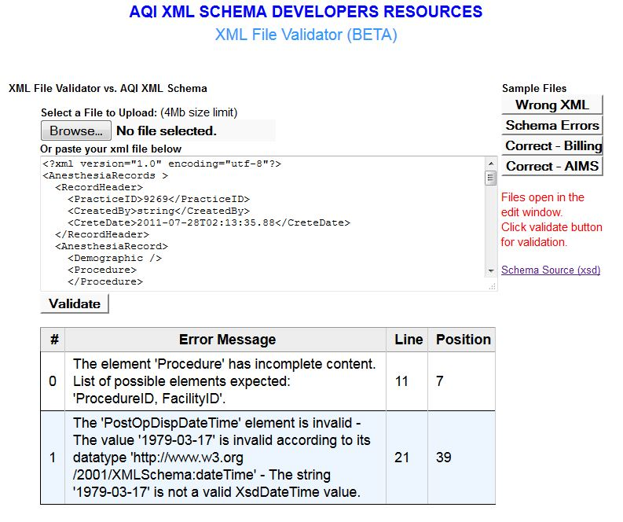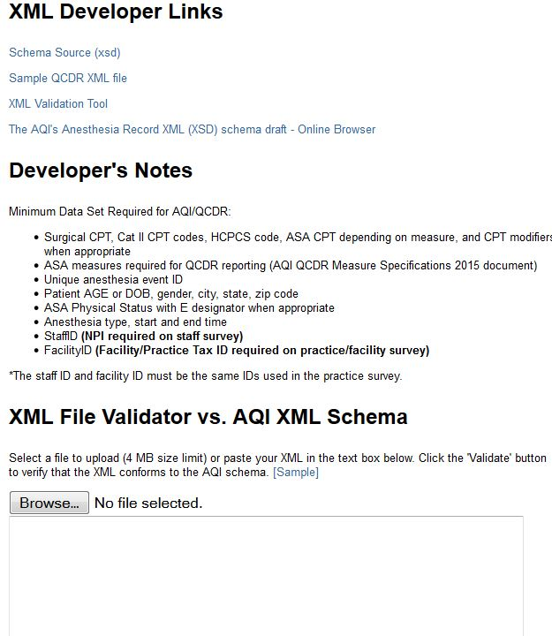

Test File – One Month with Actual Data

VENDOR
AQI
XML, CSV
AQI Review
At present, AQI is trying to guide software vendors developing their XML extract. AQI IT checks a test XML file containing one month of actual data. AQI IT manually parses the data file and runs the data validation step by step checking for errors in the file format, XML (or CSV) schema, data types, and variable enumerations. Once the file is approved by AQI there is no more manual validation. AQI would detect if software vendors change their XML schema/extract, largely changes would cause the process to produce errors while loading data.
Steps performed by AQI with the validation:
- Generate XSD schema of the testing file.
- Run the file though AQI XML parser.
- Validate extracted data (distribution, reference values, Staff and Facility ID mappings )
- Inform practice with the findings and usually provide an xml fragment of how data should be submitted.
- Repeat with the next test submission.
In a majority of cases only one iteration of test/validate is needed.

Manual Test File Validation
One a test file is submitted, AQI IT processes the file without moving the data to the production environment (i.e. the NACOR database). We inspect and examine the data atevery step of the process (i.e. parsing, populating staging databases, expected variables and their respective data types, and enumerated values).
The table below summarizes main inspection points.
Validation | Description
Schema  Missing Fields | Validation routines check for missing required variables such as (but not limited to) CPT codes, anesthesia types, date of service, anesthesia start and end times, provider / facility ID’s, and ASA physical status.
Schema  Ranges/Formats/Logic | Validation routines to check Date/Times, Age, Anesthesia CPT, Surgical CPT, Anesthesia Type, Staff Roles, Admission Type, Starts Time < End Time; DOS > Admit Date;
Data  Missing/Distribution | Validation routines check the distribution of of cases without patient age, CPT codes, start and end times by percentage.  Unusual distributions of data indicate possible issues with the data extract process, or data submission process and those files are flagged for review with the practice.
Data  Variable Enumerations | Routines to code variable enumerations such as providers, facilities, anesthesia types, airway management, ASA physical status…
Miscellaneous | Validation of XML node names to include XML node name spelling errors

List Typical Errors
The table below shows typical errors and inaccuracies found in the testing files. The list is used as a guide for ‘things to look for’ when inspecting new file.
Error Type | Description
Schema/Wrong Element | Surgical CPTs are in wrong place in XML; Misspelled element names such as CPTSets instead of CPTSet
Missing Element | Anesthesia Type Missing; Start and or End times are missing
Distribution | ASA PS I and II are missing; Only 20% of case have Age specified
Data | Staff IDs and FacilityIDs are not matching ID from practice survey
Formats | Use standard values for data: admission type; staff role/responsibility
misc | Do not default to OTHER data values (anesthesia type)

Data Loading Overview
Data loading follows pre-defined steps.
- Daily scan of FTP server and the web server loads table to select new files. Recording of PracticeID and new files (where the process status variable = 0). This information is subsequently used by the loading program for processing all files with the process status variable is 0).

- Run loading procedure (loop though all new files)
- Move file to be processed to the loading server
- Extract data (parsing) into flat pre-defined tables.
- Validate data (practiceID/staffID, referential, logic…)
- Clear staging before each load, populate staging (validation routines are run as staging database is populated)
- Move to NACOR
- Review data processing output logs
- If logs indicate that a load failed, investigate the errors.
- If the failure required a small correction modify the file and re-run the process, otherwise contact the practice / vendor

Data Load Systems

NACOR
STAGING
PARSED DATA
FTP
ARCHIVE DB
LOG

ANCOR SYSTEM | Description
FTP | FTP server, practices upload data to ftp server.
PARSED DATA | Flat Tables with extracted data (main validation)
STAGING | Cleaned data for a specific load – all fields already mapped.  All staging data removed between loads
NACOR | Transfer of all data from staging into NACOR
ARCHIVE DB | Tables with raw data a data file or from xml parsing.
LOG | Set of table for logging information.

Data Load Recording
The loading process is recording/processing all load runs (start/end time, load type, practiceID, and status). The run entries are created by the scan (section above) or manually.
Run id | stDate | PracticeID | LoadType | (No column name) | ProcessStatus
5526 | 08:49.3 | 380 | PPMPLUS | HROUGH_01_31_2015.CS | 1
5525 | 00:36.4 | 380 | PPMPLUS | HROUGH_01_31_2015.CS | 1
5524 | 56:24.5 | 380 | PPMPLUS | HROUGH_12_31_2014.CS | 1
5523 | 56:24.5 | 380 | PPMPLUS | HROUGH_01_31_2015.CS | 1
5522 | 46:30.7 | 132 | PPMPLUS | QI REPORT 2014 12.CS | 1
5521 | 45:37.3 | 132 | PPMPLUS | QI REPORT 2014 12.CS | 1
5520 | 32:35.1 | 280 | XML_280 | NULL | 1
5514 | 15:33.0 | 324 | XML_Conv_324 | nv_2015_02_24_All.tx | 1

For each run we record all the steps of the loading process. The detailed log of all the steps help us to determine the cause if data failed to load. In addition the process details log provides us with additional information about number of cases, new staff, facilities and count of all data elements extracted.
Table below shows details of a simple ABC file load:
LoadIDFK | stDate | MessageA | ValueA | ValueSt
6708 | 3/12/15 2:44 PM | Prod: EndOfStageToProd | 0
6708 | 3/12/15 2:44 PM | Prod: IntubationDetails | 0
6708 | 3/12/15 2:44 PM | Prod: TotalOutput | 0
6708 | 3/12/15 2:44 PM | Prod: AnesthesiaStaffOther | 0
6708 | 3/12/15 2:44 PM | Prod: EventOutputs | 0
6708 | 3/12/15 2:44 PM | Prod: TotalMedication | 0
6708 | 3/12/15 2:44 PM | Prod: EventTiming | 0
6708 | 3/12/15 2:44 PM | Prod: MeasurementAIMSIntraOp | 0
6708 | 3/12/15 2:44 PM | Prod: EventMed | 0
6708 | 3/12/15 2:44 PM | Prod: Post OpLabs | 0
6708 | 3/12/15 2:44 PM | Prod: PreOpLabs | 0
6708 | 3/12/15 2:44 PM | Prod: PreOpRisk | 0
6708 | 3/12/15 2:44 PM | Prod: AnesthesiaDetails | 0
6708 | 3/12/15 2:44 PM | Prod: PostOP | 0
6708 | 3/12/15 2:44 PM | Prod: Staff | 4136
6708 | 3/12/15 2:44 PM | Prod: Pay Info | 1905
6708 | 3/12/15 2:44 PM | Prod: ICD | 2843
6708 | 3/12/15 2:44 PM | Prod: PREOP | 1905
6708 | 3/12/15 2:44 PM | Prod: ASA CTP | 1905
6708 | 3/12/15 2:44 PM | Prod: CTP | 3621
6708 | 3/12/15 2:44 PM | Prod: Procedures | 1905
6708 | 3/12/15 2:44 PM | Prod: AneCQI | 0
6708 | 3/12/15 2:44 PM | Prod: AnesType | 1944
6708 | 3/12/15 2:44 PM | Prod: AirWayManagement | 0
6708 | 3/12/15 2:44 PM | Prod: Demographics | 1905
6708 | 3/12/15 2:44 PM | Prod: Cases | 1905
6708 | 3/12/15 2:44 PM | StageAirwayManagement | 0
6708 | 3/12/15 2:44 PM | StageAnesthesiaStaffOther | 0
6708 | 3/12/15 2:44 PM | StagePostOPLabs | 0
6708 | 3/12/15 2:44 PM | StagePreOPLabs | 0
6708 | 3/12/15 2:44 PM | StageMeasurementAIMSIntraOp | 0
6708 | 3/12/15 2:44 PM | StageMap_PreOP_Risk | 0
6708 | 3/12/15 2:44 PM | StageEventTimes | 0
6708 | 3/12/15 2:44 PM | StageEventOutputs | 0
6708 | 3/12/15 2:44 PM | StageEventMedication | 0
6708 | 3/12/15 2:44 PM | StageAnesthesiaDetails | 0
6708 | 3/12/15 2:44 PM | StagePostOP | 0
6708 | 3/12/15 2:44 PM | StageIntubationDetails | 0
6708 | 3/12/15 2:44 PM | StageTotalOutput | 0
6708 | 3/12/15 2:44 PM | StageMap_Anesth_CQI | 0
6708 | 3/12/15 2:44 PM | StageProcedure | 1905
6708 | 3/12/15 2:44 PM | StagePreOP | 1905
6708 | 3/12/15 2:44 PM | StagePaymentInfo | 1905
6708 | 3/12/15 2:44 PM | StageMap_Procedure_CPT | 3621
6708 | 3/12/15 2:44 PM | StageMap_PreOP_ICD | 2843
6708 | 3/12/15 2:44 PM | StageDemographics | 1905
6708 | 3/12/15 2:44 PM | StageAnesthesiaType | 1944
6708 | 3/12/15 2:44 PM | StageAnesthesiaStaff | 4136
6708 | 3/12/15 2:44 PM | StageAnesthesiaCases | 1905
6708 | 3/12/15 2:44 PM | Map_StageProcedure_ASACPT | 1905
6708 | 3/12/15 2:44 PM | Stage: StageToProd Start | 0
6708 | 3/12/15 2:44 PM | Stage:ABC Coverage Type Update Count | 1845
6708 | 3/12/15 2:44 PM | Staff Inserted | 4136
6708 | 3/12/15 2:44 PM | Stage:ABC Payment Count | 1905
6708 | 3/12/15 2:44 PM | Stage-ABC: ICD Count | 2843
6708 | 3/12/15 2:44 PM | Stage: PreOp ASA Class | 1905
6708 | 3/12/15 2:44 PM | Stage: PreOpCount | 1905
6708 | 3/12/15 2:44 PM | Stage: Procedures Loaction Update | 1905
6708 | 3/12/15 2:44 PM | ASACTP Inserted | 1905
6708 | 3/12/15 2:44 PM | CTPMainnount | 3621
6708 | 3/12/15 2:44 PM | Stage: ProcedureCount | 1905
6708 | 3/12/15 2:44 PM | Age Updated | 1905
6708 | 3/12/15 2:44 PM | DemographicsCount | 1905
6708 | 3/12/15 2:44 PM | Stage: UK States | 0
6708 | 3/12/15 2:44 PM | Stage: AnesthesiaTypeCount | 1944
6708 | 3/12/15 2:43 PM | Stage: Anesthesia Cases Count | 1905
6708 | 3/12/15 2:43 PM | Stage: Wrong Cases Count | 0
6708 | 3/12/15 2:43 PM | New Facility In Web | 0
6708 | 3/12/15 2:43 PM | New Facilities In NACOR | 0
6708 | 3/12/15 2:43 PM | Missing Faciliites In Web | 0
6708 | 3/12/15 2:43 PM | Missing Staff In Web - STU CRNA | 0
6708 | 3/12/15 2:43 PM | Missing Staff In Web - RESIDE | 0
6708 | 3/12/15 2:43 PM | Missing Staff In Web - MD | 0
6708 | 3/12/15 2:43 PM | Missing Staff In Web - CRNA | 0
6708 | 3/12/15 2:43 PM | Missing Staff In Web - MD | 0
6708 | 3/12/15 2:43 PM | CasesInNacor | 0
6708 | 3/12/15 2:43 PM | StartABCInsert | 333
6708 | 3/12/15 2:43 PM | FileCopied | 333 | /users/abc_saa/AMAA_AQI-RANGE_010115-013115_N.txt
6708 | 3/12/15 2:43 PM | PackageExecute | 333 | /f C:\0000AQIAutoLoad\ABCLoad.dtsx /De x
6708 | 3/12/15 2:43 PM | Stage: All Tables Truncated | 0
6708 | 3/12/15 2:43 PM | Started Load | 6708

Data Validation
Each processed data file goes through three stages of processing: Data parsing (extract of data) – Parser/Extract Validation, Pre Stage Processing (Pre Stage Validation), Production and Stage Validation.

Parser/Extract Validation

PARSED DATA
FTP
The step involves extracting data from xml or flat file into pre-defined flat tables.
During this step there is a ‘hard stop’ of the processing of the file if:
- File is not properly formatted (xml parsing) or bulk insert of a flat file (csv) fails.
- There are over 3 new facilities
- There are over 10 new staff members

Load details entries help determine the cause

Pre Stage Validation
NACOR’s incoming data currently comes from over 100 different sources. Data validation at this level is source specific. The validation process here is concerned about the structure and format of the data. The meaning of the data is taken into consideration in the second phase of validation (post insertion auditing).
All steps of the pre-stage validation are recorded in a log table.
Termination of the current loading process if:
- New reference types
- Formatting of dates

Load details entries help determine the cause. At this point if it is possible AQI is manually update reference mapping (AQI is updates reference mapping not the reference). We follow it with re-run the process.
Referential Coding/Mapping Validation
Termination of the current loading process if:
- New reference types (enumerated values not on the approved list)
- Formatting of dates
Load details entries help determine the cause.

The translation of source specific data elements to a single common format is the next step in the validation process. Values of data elements that are not currently present in our common definition libraries are flagged and scrutinized for accuracy. If the new value is valid it is added to our common definitions and assigned a proper code or AQI mapping is updated. Values that are determined to be invalid are removed If the data element containing it is determined to be crucial the record in question will be rejected.
Coding/Mapping validation safeguards referential integrity of data in NACOR and serves as discovery process of new values (new anesthesia type, airway maintenance, units, routes, etc…).

Sample of the mapping fields include:
Anesthesia type
US States
Gender
Units
Admission Type
Staff Role
Coverage Type
TimeEvents
Outcomes
Data Type validation
Regardless of what is sent to NACOR, all members of the same field must share the same “type.”
Whatever the data type (integer, decimal, free-text) it must be uniform for all entries of the same field.
Validate if all dates/times fields are correct are correctly formatted as date/time format.
Validation of all numeric types (age, dose, concentration, etc.)

Validation of ranges/formats
After a type has been determined the proper formatting and range checking can be applied. Some conditional logic may be applied at this time.

All ages must be integers (data type validation) and within a range of 0 – 110.
Zip code are valid five digit codes.
All anesthesia codes are numeric values and must be between “00100” and “01999”.
ASA Physical Statusranges between 1 and 6

Logic validation
With all fields verified to be of correct data types and to be in the acceptable range, ,some “business” logic regarding the data can be performed. This is also the point at which records missing crucial data elements may be deleted from the dataset.

Admission date must be <= the surgery date.
Starts Time < End Time
DOS > Admit Date
Discharge Date >= DOS
Records missing required data elements: Anesthesia Type, Start/End Time, Staff are deleted

Production and Stage Load Validation
At the moment when data is in the staging tables it is already validated and all values are mapped to NACOR references.
The only check is comparing and counting data elements in in the staging tables.
Sample output:
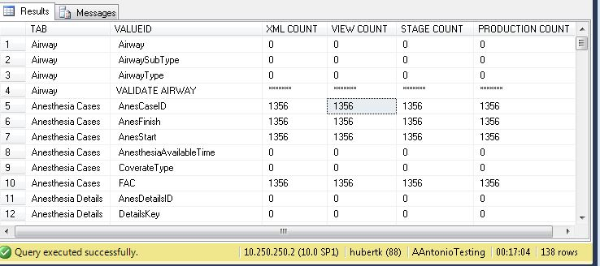

Post insert auditing (all NACOR cases as well as drill down to practice level)

Daily (nightly) NACOR validation
All records in the registry undergo continual auditing on a daily basis. These audits include redundant checks from the pre-insertion validation routines as well as validations based on historically collected data. This trend analysis is performed in two different ways. The first involves comparing case data over case time (the time at which anesthesia was performed for each case). The other involves comparing case data by the date it was loaded.
Comparing data over case time helps to determine the consistency of data from any particular data source. Key data elements in NACOR (# of cases, emergency status of cases, etc.) are stratified by case time and rates are generated by month. Any stratification yielding high variability where it is unexpected are flagged and scrutinized by AQI staff.
Comparing data by load date helps determine the reliability of any particular data source. Again, key data elements (ASA physical status, patient age, etc) are crossed with the date they were loaded into NACOR. An inventory of the range of enumerated values by data element and load date is compared across all loading dates. A data source that has discrepancies by load date may need to be looked at more closely.
In either type of the daily post insertion audit trend analysis validation techniques, whether no flags are raised or potential problems are detected, a log is created to reflect the current status of NACOR’s health. This log and report is generated, read, and acted upon daily.

ValidationCategory | ValidationSubCategory | ValidationDesc
AnesType | Orphan Anestesia | Anesthesia Type entries not associated with any Anesthesia Case
AnesType | Missing Anesthesia Type | Cases with no Anesthesia Type Specified
AnesType | Duplicate AnestType Records | Duplicate Anesthesia types in the AnesthesiaType table
Cases | Missing Months | Missing Months per Practice
Cases | Duplicate Loads | Number of cases per month is unusually high - indication of multiple loads.
Cases | AnesthesiasTime | Anesthesia Start Time is after Anesthesia End Time
Cases | AnesthesiaStartTime | NULL || < 2010 || > current
CPT | Cases w/o CPT | Cases in NACOR that do not have an entry in the map_procedure_cpt table
Demographics | Duplicate Demographics Records | Duplicate Demographics Records
Demographics | Orphan Demographics | Demographics entries not associated with any Anesthesia
Demographics | Age Missing | Age is missing from demographics
Demographics | DOB | DOB < 1895 or DOB > AnesthesiaStartTime or DOB > GETDATE(()
Demographics | Age non-correct | Age between [0,120] and Age=(DOS-DOB)
Facilities | PracticeID Missmatch | Facility (Facility PK) is assigned to different practices between WEB and NACOR
Facilities | Orphan Facilites | Orphan facilities - Facilities in anesthesia record (FacilityID) points to non existing facility in PracticeFacility table.
Facilities | CaseFacilityPractice Missmatch | Based on FacilitiesID - Anesthesia case points to different Practice than Facilitie associated with the case.
Facilities | Case - NULL Facilities | Anesthesia Case has no facility associated facility.
PreOp | ASA Class Missing | Missing ASA classes (from I to IV) in the last load.
PreOp | Orphant PreOp | Orphan Pre-Op - PreOp anesthesia fk points to non existing anesthesia record.
Procedure | AdmissionDate | AdmissionDate < 2010 OR > GETDATE()
Procedure | Multiple Procedures | Duplicate Procedures in the Procedure table
Staff | SignIn Time | SignIn < AnesthesiaStartTime
Staff | SignOut Time | SignOut > AnesthesiaFinishTime
Staff | Staff Orphan in Nacor | Staff in NACOR with no entry on the WEB practicestaff table.
Staff | Dormant Staff | Staff with no cases assigned to them
Staff | Multiple Staff ID | Multiple staffID for a practice. Indicating multiple entries for the same provider in the PracticeStaff table.
Staff | Cases w/o Staff | Cases in NACOR that do not have an entry in the AnesthesiaStaff table meaning there are no providers assigned to the case

Reporting
There is an on-line report when a user can see the result from the daily validation script (the data can be drilled down by practice)
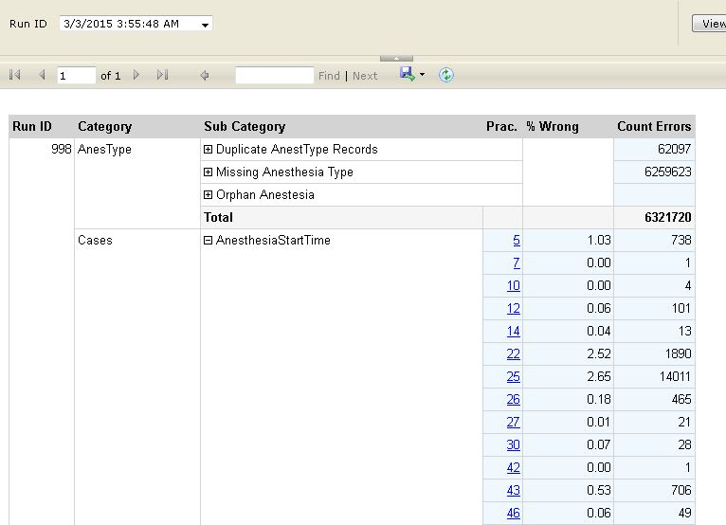

NACOR Validation Summary

Validation Stages
- Pre-Stage Validation
- Pre-Production Validation
- Post Insert Auditing
NOTE: All validation results are recorded in the validation log DB tables.

STAGING DB
NACOR DB
FTP SERVER
VALIDATION LOG DB
REPORTS
Pre Stage Validation
Source specific. Validation of the structure and format of the data. (see details)
Pre-Production Validation
Case level data integrity. Validation in the staging DB prior to NACOR insertion. (See details)
DAILY (NIGHTLY) Post insert auditing
All records in the registry undergo auditing: This trend analysis, consistency of data from any particular data source. (see details)

